**Day4**

C++ Class & Object

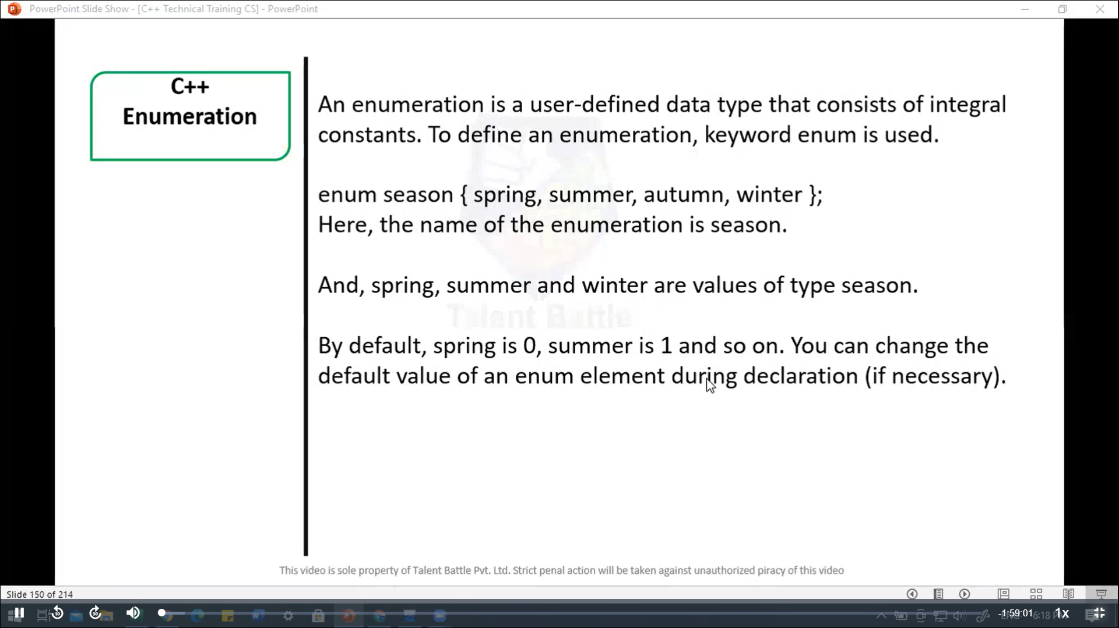

// Enumeration

#include <iostream>

using namespace ***std***;

enum week { Sunday***,*** Monday***,*** Tuesday***,*** Wednesday***,*** Thrsday***,*** Friday***,*** saturday

};

int *main*(){

  week today;

  today = Wednesday;

  cout ***<<*** "Day" ***<<*** today + 1;

  return 0;

}

/*

Day4

--------------------------------

Process exited after 0.1415 seconds with return value 0

*/

//=========================================================

// Enumeration ex: 2

#include <iostream>

using namespace ***std***;

enum seasons{

  spring = 34***,***

  summer = 4***,***

  automn = 9***,***

  winter = 32

};

int *main*(){

  seasons s;

  s = summer;

  cout *<<* "Summer = " *<<* s *<<* *endl*;

  return 0;

}

/*

Summer = 4

--------------------------------

Process exited after 0.01113 seconds with return value 0

*/